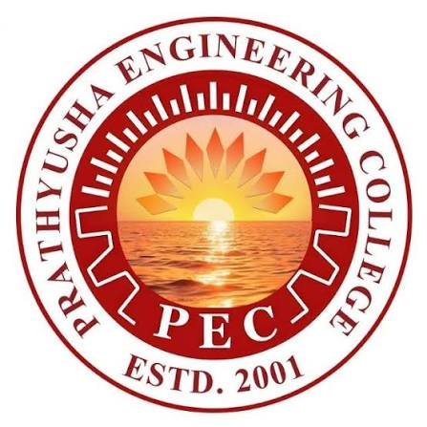

PRATHYUSHA ENGINEERING COLLEGE
(An Autonomous Institution)

HACKATHON ACHIEVERS
HONOURED BY MANAGEMENT ON RESEARCH DAY - 15.10.26

ODD SEMESTER
2026-2027

HACKATHON ACHIEVERS
HONOURED BY MANAGEMENT ON RESEARCH DAY - 15.10.26

ODD SEMESTER 2026-2027

S.No | NAME | DEPT/YR | NAME OF THE HACKATHON | DATE | AWARD | PRICE MONEY
1 | NAVEEN V | AIML/II | BHARAT SHAKTHI TRACK  DECODE SIH 2026 | 01 AUG  2026 | FIRST | 30,000/-
1 | NAVEEN BASKER | AIML/II
1 | SHIVANI MOHAN | AIDS/II
1 | SWEETY JOSE J | AIDS/II
1 | JEEVA ANAND | AIML/II
2 | GOPI KRISHNA | AIML/IV | TECHNOVA 2026 | 13 SEP  2026 | FIRST | 25,000/-
2 | VISHAL | CSBS/III
2 | TANUSREE | CSBS/III
2 | PAVITHRA | AIDS/IV
2 | DHANASREE
3 | SHAM KUMAR | BIOTECH/IV | SUSTAINVERSE 2026 | 15-16  SEP  2026 | SECOND | 5,000/-
3 | DHANA SHREE | BIOTECH/IV
3 | BHOOMIKA | BIOTECH/IV
3 | NARESH | ECE/II
4 | THEJASVANI S | CSE/III | VYNORAE 2026 | 21-22 AUG  2026 | FIRST | 20,000/-
4 | VAISHNAVI DEVI G | CSE/III
4 | YOGITHA SG | CSE/III
5 | TANUSREE | CSBS / III | TECH THIRUVIZHA 2026 | 25 AUG  2026 | SECOND | 5000/-
5 | VISHAL | CSBS/III
5 | JEFFRY JOYSON | CSBS/II
6 | KAVIYA | CSBS/III | HACK DAY GENESIS 2026 | 30  SEP  2026 | SECOND | 1000/-
6 | SHANTHOSH | CSE/III
6 | Sakthi Priya | CSE/III
6 | Yazhini | CSE/III
7 | KAVIYA | CSBS/III | FUTURE FORGE 2K26 | 5TH & 6TH OCT 2026 | SECOND | 8000/-
7 | SHANTHOSH | CSE/III
7 | Sakthi Priya | CSE/III
7 | Yazhini | CSE/III
TOTAL |  |  |  |  |  | 94,000/-

